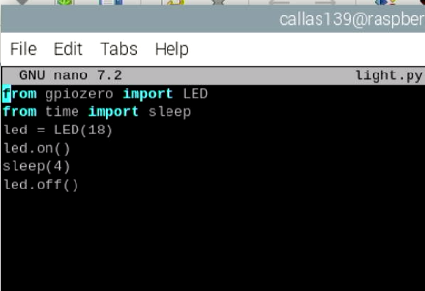

Questions:

* The purpose of the breadboard is to be able for testing and prototyping as well as allowing for quick changes and improvements to the code/electronic stuff.
* Yes the LED orientation matters because if it is incorrect then the led will not light up and it can block the entire circuit, proceeding to cause problems. The anode and cathode sides to the led show which side should be on which.
* You put a resistor on your circuit so that when the electrical currents go through the wiring and then the led, the led doesn’t explode because it cannot handle the amount of energy in just the circuit.
* A resistor with more resistance will make the light dimmer and dimmer since the resistor tamps down the electricity running to the light and if the resistor is very strong then the electrical current will be smaller, making the led dimmer.